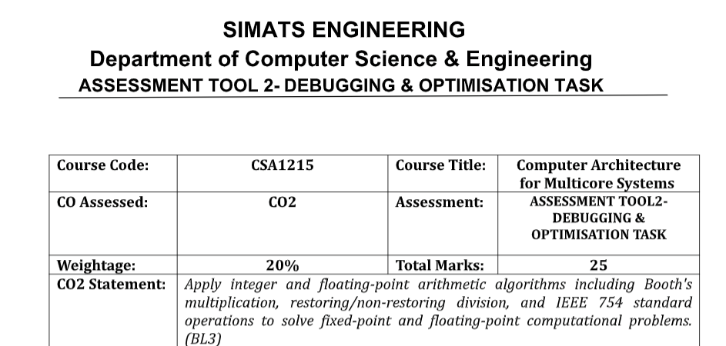
NAME : ROSHAN K
REG NO: 192425014
DEPARTMENT: AI &amp; ML
DATE : 03-08-2026

1. Debugging Signed Integer Addition (2's Complement Overflow)
Problem
A program adds +120 and +50 using 8-bit 2's complement.

Step 1: Convert to Binary
+120 = 01111000
+50 = 00110010

Step 2: Perform Addition
01111000
+ 00110010
------------
10101010
Binary result:
10101010
Interpreted as a signed 8-bit number:
10101010 = -86
Expected mathematical result:
120 + 50 = 170
Since the 8-bit signed range is:
-128 to +127
170 cannot be represented.

Overflow Detection
Overflow occurs because:
- Both operands are positive
- Result becomes negative
Another detection method:
Overflow = Carry into MSB ⊕ Carry out of MSB
If XOR = 1, overflow has occurred.

Debugging Result
Cause:
- Arithmetic overflow due to limited 8-bit range.

Solution
- Check overflow after every signed addition.
- If overflow occurs:
  - Display an overflow error.
  - Use a larger data type (16-bit or 32-bit integer).
  - Prevent incorrect signed interpretation.

2. Debugging Ripple Carry Adder Delay
Problem
A ripple carry adder is slow because each carry must propagate through every bit.

Carry Propagation
Example:
A = 1011
B = 0110
Carry flow:
Bit0 → Bit1 → Bit2 → Bit3
Each bit waits for the previous carry.
If one full adder delay is T, then
Total delay = 4T
For larger adders:
32-bit → 32T
64-bit → 64T
Delay becomes significant.

Performance Bottleneck
The critical path is the carry chain.
Every stage must wait before computing the next carry.

Optimized Solution: Carry Look-Ahead Adder (CLA)
CLA computes carries in parallel.
Generate signal:
Gi = Ai · Bi
Propagate signal:
Pi = Ai ⊕ Bi
Carry equations:
C1 = G0 + P0C0

C2 = G1 + P1G0 + P1P0C0

C3 = G2 + P2G1 + P2P1G0 + P2P1P0C0
Carries are available simultaneously.

Improvement
Ripple Carry Adder | Carry Look-Ahead Adder
Sequential carry propagation | Parallel carry computation
High delay | Low delay
Simple hardware | More hardware
Slow for large adders | Fast for processors

3. Debugging Booth's Multiplication
Problem
Booth's algorithm gives incorrect results for negative numbers.

Correct Booth Rules
Q₀Q₋₁ | Operation
00 | No operation
11 | No operation
01 | A = A + M
10 | A = A − M
After each operation:
Arithmetic Right Shift

Common Errors
1. Incorrect Bit-Pair Checking
Using
Q1Q0
instead of
Q0Q−1
produces incorrect operations.

2. Logical Shift Instead of Arithmetic Shift
Incorrect:
01010010
Correct arithmetic shift preserves the sign bit.
Negative numbers require:
11101001
not
01101001

3. Incorrect Sign Extension
The sign bit must be copied during shifts.
Without sign extension:
Negative numbers become positive.

4. Wrong 2's Complement
Incorrect subtraction causes all later steps to fail.

Corrections
- Always compare Q₀Q₋₁.
- Use arithmetic right shift.
- Preserve the sign bit.
- Verify the 2's complement of negative operands.
- Repeat exactly n iterations for n-bit numbers.

4. Debugging Restoring Division
Problem
Restoring division performs unnecessary restore operations.

Workflow
For every iteration:
- Shift left
- Subtract divisor
- If remainder is negative
Restore remainder
- Set quotient bit

Inefficiency
Whenever subtraction produces a negative remainder:
Restore
means
Subtract
+
Add back
Two arithmetic operations are required.
This increases execution time.

Optimized Solution: Non-Restoring Division
Instead of restoring immediately:
- If remainder is positive
Subtract divisor
- If remainder is negative
Add divisor in the next iteration
Only one final correction is required if the remainder is negative.

Comparison
Restoring | Non-Restoring
Frequent restoration | No immediate restoration
More additions | Fewer additions
Higher execution time | Lower execution time
Lower efficiency | Higher efficiency

Performance Improvement
- Fewer arithmetic operations.
- Reduced execution cycles.
- Better hardware utilization.
- Preferred in modern processors.

5. Debugging IEEE 754 Floating-Point Addition
Problem
Adding a very small number to a very large number produces inaccurate results.
Example:
100000000 + 0.000001

Step 1: Exponent Alignment
Floating-point numbers must have the same exponent.
The smaller number's mantissa is shifted right.
Example:
Large exponent

1.010101 × 2²⁷

Small exponent

1.000000 × 2⁻²⁰
The small mantissa is shifted many positions.
Most bits disappear.

Step 2: Mantissa Addition
After shifting:
Small mantissa ≈ 000000000001
Adding it to the large mantissa changes almost nothing.

Step 3: Normalization
After addition:
- Normalize the result.
- Adjust the exponent if necessary.

Step 4: Rounding
IEEE 754 rounds the mantissa.
Lost bits are discarded.
This introduces small errors.

Causes of Inaccuracy
- Large exponent difference.
- Loss of significant digits during alignment.
- Rounding after normalization.
- Limited 23-bit mantissa in single precision.

Optimization Techniques
1. Use Double Precision
Single Precision | Double Precision
32 bits | 64 bits
23-bit mantissa | 52-bit mantissa
Lower accuracy | Higher accuracy
Double precision significantly reduces rounding and precision loss.

2. Rearrange Computations
Add numbers of similar magnitude first.
Example:
(a + b) + c
instead of
a + (b + c)
when a is much larger than b and c.

3. Compensated Summation
Use algorithms such as Kahan Summation to reduce accumulated rounding errors.

4. Scale Values
Normalize or scale inputs before performing arithmetic to reduce exponent differences.

5. Avoid Repeated Conversions
Minimize unnecessary conversions between floating-point formats, as repeated conversions can introduce additional rounding errors.

